Dew Drops Little Flower
The story behind Dew Drops:
Four years ago, at a state-run orphanage, Lily (Program Director of Dew Drops Little Flower) met Fei for the first time. Lily was there to bring back another child who was born prematurely and needed special care. But Fei’s face captured Lily and he left a lasting impression on her. Fei was extremely thin and fragile. Lily was informed that he did not eat well and so he was very tiny. A few days later, Fei came to Little Flower’s baby home. He seemed to have lost even more weight. At 4 months old, he only weighed 3 kilograms (around 6.6 pounds).
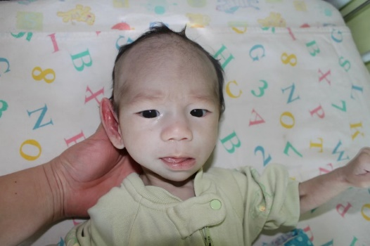
Fei was born with a heart defect. Surgery for his specific type of defect is typically quite successful. But because Fei weighed very little and was very weak, he was not ready for surgery. This is where his journey to grow and become stronger began! Within 1 month, Fei put on a significant amount of weight. Can you believe this is the same child? His weight gain highlights the positive outcomes possible with love and specialized treatment.
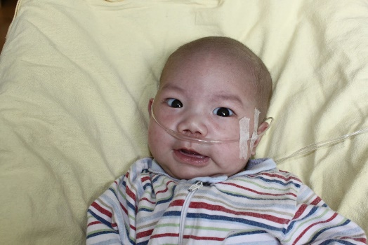
In four months’ time, he was ready for his surgery. Look at how much he has changed within such a short time.
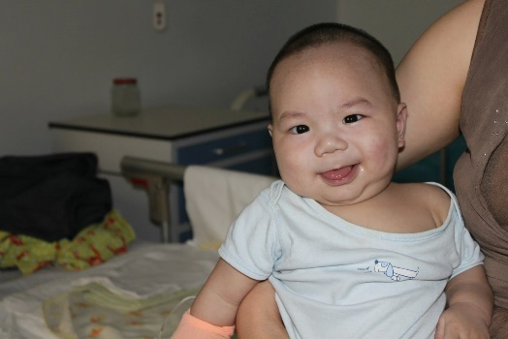
His heart surgery was successful and after receiving post-operative care, he finally returned back to the baby home.
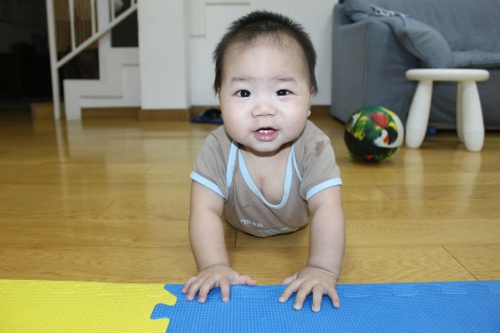
Over time, Fei continued to grow. Since he had full repair surgery and no longer needed special treatment, he was transferred to another organization while he waited to be adopted.
Now, Fei is 4 years old and with his forever family. He is a healthy, happy boy!
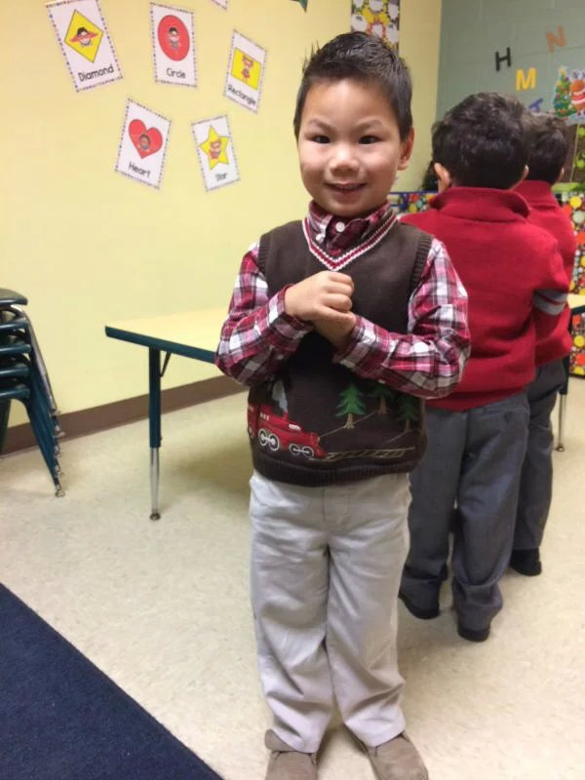

This is just one example of a child’s story that highlights the power of love and specialized treatment. Fei’s life was saved and forever changed.

“We know only too well that what we are doing is nothing more than a drop in the ocean. But if the drop were not there, the ocean would be missing something.” - Mother Teresa

Please join us in providing a future to children in need. Together we can make a difference.

